

**EC315 Summary (1):**

**Topics in Microeconomics With Cross Section Econometrics**

**Lewis Britton {201724452}**

EC315: Topics in Microeconomics With Cross Section Econometrics

Academic Year 2019/2020

Word Count: {N/A}

**EC315: Topics in Microeconomics With Cross Section Econometrics**

**Topic Summary**

**Topics:**

1. **Exam Summary**
2. **Game Theory (Externalities & Consequences)**
3. Topics in Public Economics (Government Role & Functions)
4. Cross-Section Economics (Theory & Real World)

**Assumptions:**

1. No individual has a significant influence on a market.
2. Perfect information exists.
3. There are no external effects on production/consumption.
4. No ‘public goods’.

**Exam Summary**

**Cost Benefit Analysis Summary**

1. **Purpose**
2. **Alternatives**
3. **Who?**
4. **C/B Impacts**
5. **Lifetime** **Impacts**
6. **Monetize**:
   * Social Costs: harm done to living organisms
   * Revealed/Stated Preference: willingness to pay **or** willingness to accept
     + Revealed: shown in behaviour
     + Stated: questionnaires etc.
   * Time:
     + Work **vs** Leisure: use wage rate – but some skewed
     + Travel Time: how much people willing go out of way (e.g. high pay)
   * Lives: Life Expectancy, Pay, Age, Risks Taken
   * Natural Resources: AONBs, surveys, investment, regulation
   * *Marginal B. = Marginal C.: no external costs (Monetary C. = Real C.)*
   * [Willingness to Pay/Accept]
   * [Stated/Revealed Preferences]
7. **PV Discounts**
   * Social Discount Rate
   * Intergenerational: More than 50 years (3.5%)
8. **NPV of Alternatives**
9. **Sensitivity Analysis**
10. **Recommend**

**Programme & Policy Evaluation Summary**

1. Cause (Intermediaries) Effect
   * [Selection Bias]: E.g. grades, income, area
2. **Omitted** **Variable** **Bias**
   * [Selection Bias]: E.g. effort, determination, stamina
3. **Randomised Control Trial**
   * [Unbiased Estimator]: (LLN)
   * [Unbiased Estimator]: Randomisation
   * []: “How much of result is chance?”
   * [t-tests]: Causal Effect (
4. **Regression**:
   * [Dummies]: Causal Variable/Group
   * [IVs]: Omitted Variables ()
5. **Impossible**:
   * Logistical, Ethical, Lack of Need

**Crime & Punishment Summary**

* + 1. [Supply]:
    2. Normal Distribution
       - Req.
       - Req.
       - Morals, Enjoyment, Risk (Some Need Huge/Small Payoffs)
    3. [Demand]:
    4. Derivatives
    5. [Supply/Demand]:

**Calculations Summary**

1. [Externalities]:
2. [Strategic Nature]:
3. [Grim Trigger Strategy]:
4. [Tit-For-Tat Strategy]:

**Game Theory**

* Welfare Economics – Generalising equilibriums. Competitive markets provide an incentive for firms to produce what customers want. Markets rock if there is fair play.
  + Theorem 1 – Every competitive economy is Pareto Efficient.
  + Theorem 2 – Every Pareto Efficient allocation of resources can be achieved in competitive markets (w/ appropriate redistribution between parties).
* Pareto Efficiency – No additional person can be made better off without making someone else worse off. There should be no government intervention. Redistribution can take place meaning there is redistribution between parties within the economy rather than externally.
* Prisoner’s Dilemma – Pursuing your own interests leads to inefficient markets because, using the prison example, if both people choose to confess, they get full long time each. If they both lie, they get full short time. If one lies and one confesses, the one who confesses gets reduction but the liar gets full time. This is risk. Both could deny for 2 years of the other lies (gets 10 years). But then they both risk getting 8 years. If they both deny they both get the full short time (3 years). Denying is best for them both but confessing **could,** but only could, be best for a single one of them.
* Rationality – Players will choose the option with the best payoff for themselves. But back to the Joey and Phoebe, if you are choosing the best for yourself, surely the opponent must be doing the same so can you forecast? Or will they think the same and one-up you?
  + Common Knowledge of Rationality – Where players don’t just know they possible outcomes of their decisions, they know the possible outcomes of the other’s decisions. But recall the prisoner’s dilemma.
* Game Theory – our actions **have** external consequences. They effect the environment and all things around us (smoking example).
  + Non-Cooperative Game – in it for your own gain and only that.
  + Information Game – Everyone knows they are playing.
  + Stage Game – May be repeated (e.g. rearranging cost agreements).
  + Simultaneous Game (Type 1) – when players do not know the move of the opponent and move at the same time.
  + Sequential Game (Type 2) – when players know the move of the other player and can make their decision based on the opponent’s move.
* Imperfect/Perfect Information – not being able to see the others’ choice. Your outcome will always depend on their choice but your decision won’t. **Or**, you have information about their decision to look at as they have make it (historic forecasting).
* Strategic Uncertainty – (when simultaneous) players must base decisions on what they think the other player will play as they do not know. But then they must consider what they think the opponent’s move will be but then, the opponent will surely think they will be thinking this and so make a different move and make the same prediction about their opponent… in practice usually it comes back round to them making the first decision that you predicted they would make (Joey and Phoebe e.g.) Can lead to Strategic Payoff where the strategic nature of their thinking pays off and they’ve well forecasted the other’s choice.
* Dominant Strategy – When there is one clear winner in the strategy you use. It takes the lead the majority or all of the time when put into the matrix. This is found through Best Response Analysis which is found by going through each option of B and selecting the best strategy for A to choose (repeat for all columns of B). Then repeating for B (for all rows of A). The double underlined is the dominant strategy.
* Dominated Strategy – When the strategy a player chooses is dominated than another strategy which would make you better-off than the one you’re choosing.
* Nash Equilibrium – When there is a clear equilibrium between the players’ Dominant Strategies. Means you can’t Unilaterally Deviate and make themselves more profitable (no incentive to deviate).
  + When there is no dominant strategy: Unilateral Deviation
  + Mixed Strategies – Players randomise strategies on unpredictable patterns (e.g. with muscular workouts).
  + Pure Strategies – when the player knows for sure what option they will choose

**1: Simultaneous Move Game**

* Sole entrant: big payoff
* Both attempt entry: perhaps not enough market space
* There’s a First Mover Advantage

**1.1 Pure & Mixed Strategies**

* Note: Chicken Game: two players heading towards each other;
  1. They collide and both marginally lose out
  2. One swerves and loses out bigger (**Chicken**)
* (from Tutorial 1) there may be two Nash Equilibria.

|  |  |  |  |
| --- | --- | --- | --- |
|  | **Player B** | | |
| **Player A** |  | E (q) | N (1-q) |
| E (p) | -50,100 | 150,0 |
| N (1-p) | 0,100 | 0,0 |

* + The Nash Equilibria are underlined. There are two.
  + Pure strategies are shown through probability as seen by entering probabilities p & q above.
  + For Player A:

(EV = Expected Value)

EVA (E) = -50q + 150(1-q) EVB(E) = -100p + 100(1-p)

EVA (N) = 0q + 0(1-q) EVB(N) = 0p + 0(1-p)

-50q + 150 -150q = 0 -100p + 100(1-p) = 0

q = ¾ p = ½

* These are the probabilities of placing in the respective quartiles:

|  |  |  |
| --- | --- | --- |
|  | E ¾ | N ¼ |
| E ½ | 3/8 | 1/8 |
| N ½ | 3/8 | 1/8 |

* You are trying to find the option that would make you both indifferent between choosing options.

**2: Sequential Move Game**

* Uses Backward Induction
  + Games are analysed from the end through to start
* Transforms from Normal Form to Extensive Form
* Transforms Nash Equilibrium to Sub-Game Perfect Nash Equilibrium
* Not subject to Strategic Uncertainty(imperfect information)
  + Can observe movements
  + Hence, Perfect Information
  + E.g. supermarket price setting
* If the first or last mover has a Dominant Strategy, they’ll use it

**2.1: Game Tree**

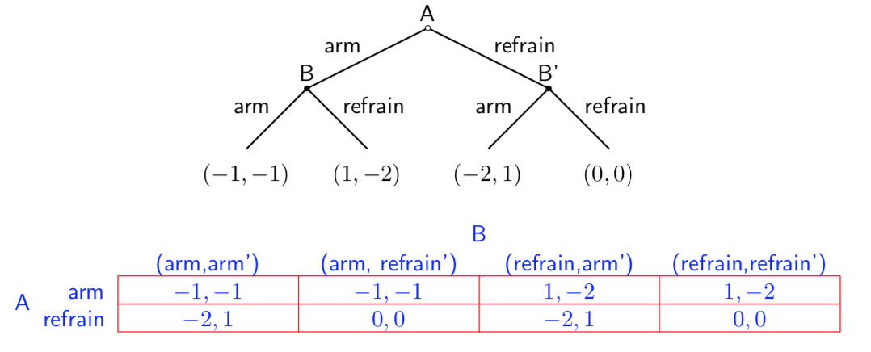

* In Simultaneous: Strategy = Action
  + Not the case in Sequential
  + Action: a simple move
  + Strategy: plan based on the move of the first player
* **A**’s Strategies:
  + Arm;
  + Refrain
* **B**’s Strategies:
  + (Arm, Arm’);
  + (Arm, Refrain’)
  + (Refrain, Arm’)
  + (Refrain, Refrain’)
* Information Set: don’t know which two nodes you are at:
* Subgame: the mini-looking games which Beta is player under Alpha

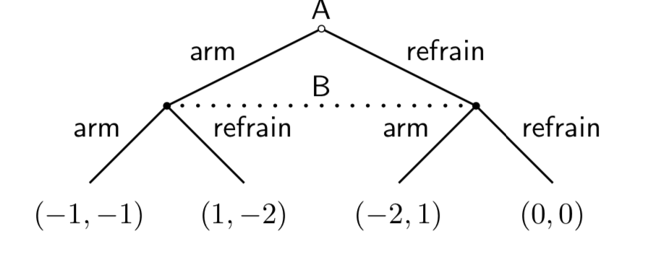

**2.2: Choosing an Option**

* **Example**:

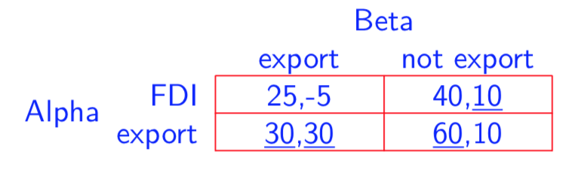

* Normal:

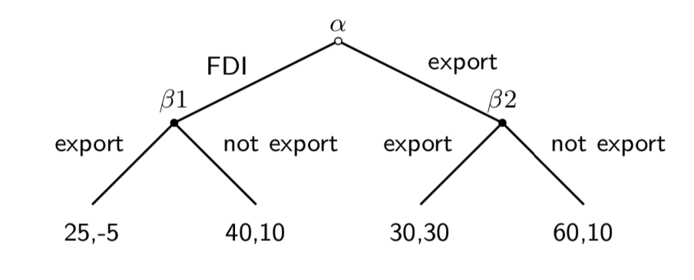

* Extensive:
* In the Normal Form, (export, export) is the Dominant Strategy
  + But **Beta** has more options
  + (export, export’) (E,E’)
  + (export, not export’) (E,N’)
  + (not export, export’) (N,E’)
  + (not export, not export’) (N,N’)
* If Alpha plays FDI, will Beta ever export?
  + (N,E’) allows Incredible Treats to be made “off the equilibrium path”

**2.3: Backward Induction**

* A process used to avoid Incredible Threats

1. Start at the last stage of the game
2. Break down into two of Alpha’s options
3. Select these two Subgame Nash Equilibria for Beta on each Alpha arm
   * Not Export and Export’ are the best for Beta here (N,E’)
4. Alpha now has a choice
   * FDI would be followed by Beta’s Not Export (40,10) [> (25,-5)]
   * Export would be followed by Beta’s Export’ (30,30) [< (60,10)]
   * Alpha plays FDI
5. Nash Equilibrium is made clear
   * {FDI,(N,E’)}

* If Alpha assumes Beta is Rational, they expect Beta to play (40,10) on FDI and (30,30) on Export
* Credible Threats:
  + Only on FDI as they could lower their payoff to punish Alpha
  + (25,-5)

**2.4: Order Advantages**

* **Commitment** (first mover) vs. **Flexibility** (follower)
  + **Commitment** has greater value in Simultaneous
  + **Flexibility** has greater value in Sequential
* Recall that in Simultaneous Games there’s a First Mover Advantage
* First Mover Advantage (Simultaneous):
  + 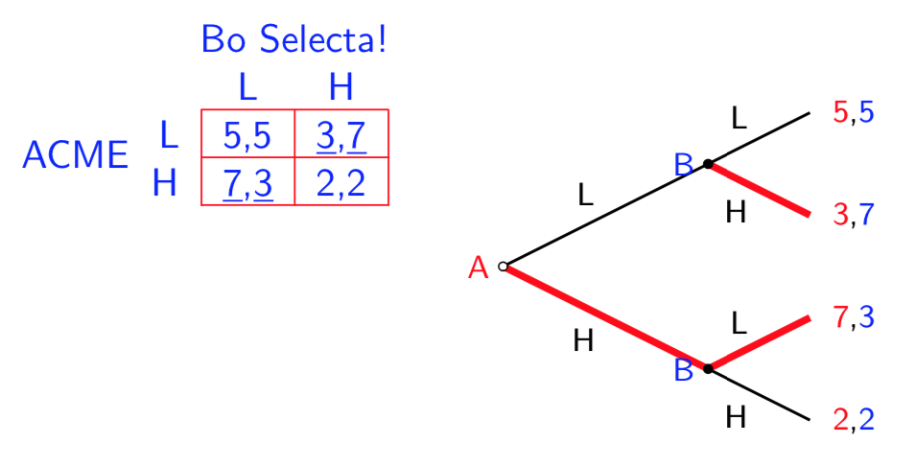
  + **B** maximises on both moves and **A** maximises on its one move
  + **A** lowers **B**’s payoff by choosing a more profitable option for them
* Second Mover Advantage (Sequential):
  + 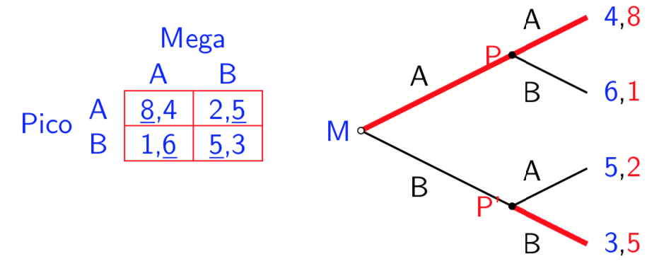
  + **M** goes for overall highest payoff (6) by choosing move A
  + **P** has the option to choose one which greater benefits them and lowers **M**’s expected payoff

**2.5: Manipulating Games**

* Take actions to manipulate a game? That is, guaranteeing an outcome
* Threats & Promises
  + “If you attack, I’ll fight…”
  + “If you enter, I’ll enter too making it less profitable for you…”
  + “If you work hard, I’ll work hard…”
  + Lacks Credibility as you could be **bluffing**
* Credibility
  + “If you’re late, ill set off a bomb…” (Incredible: bluffing? – not factual)
  + “If you’re late, the timed bomb will go off” (Credible: more believable – fact)
  + Changes first mover’s thinking

**2.6: Price Matching Guarantees**

* Standard Subgame Perfect Nash Equilibrium:

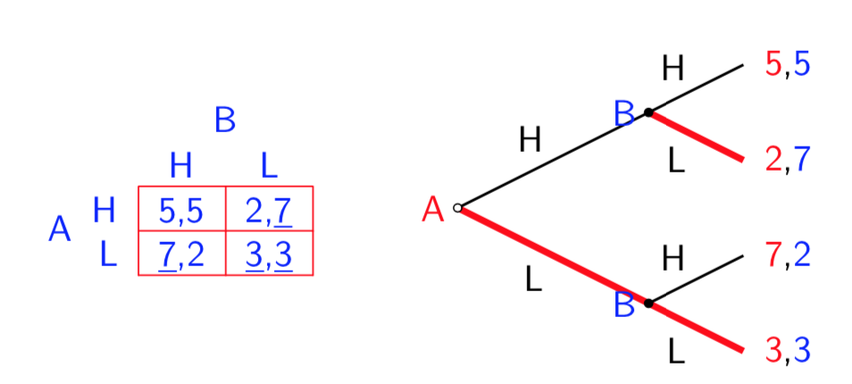

* Offering a Price Match Guarantee:

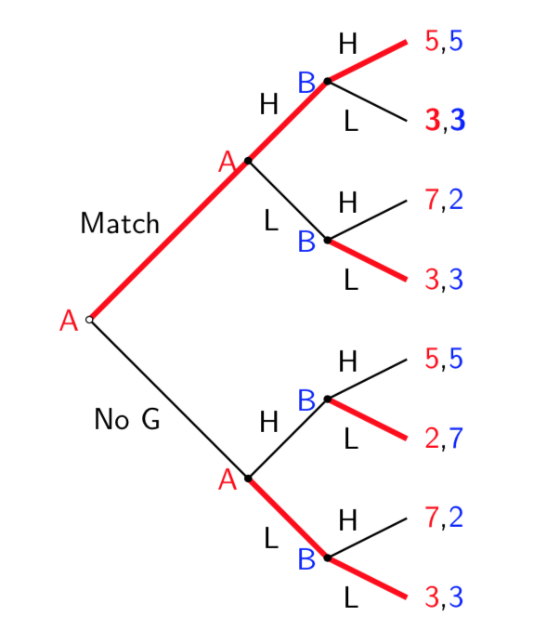

* + Commitment to maintain high prices
  + By committing to match low prices, A changes payoffs such that it’s not beneficial for B to undercut – as bigger payoff can’t be seen
  + Both firms end up paying high prices
  + (Pricing) Prisoner’s Dilemma

**3: Prisoner’s Dilemma**

* Cooperate or Defect
* Mutual Gain: Cooperate
* Individual Incentive: Defect
* Pareto Inefficient Equilibrium
* Recall: someone has a Dominant Strategy where there’s harm done to each other and they could be better off (Pareto Efficient). Self-interest doesn’t pay off. But:
  + Games can be repeated (e.g. price re-setting)
  + E.g. lower price than opponent now (get more custom volume), makes opponent less-off (also poor for aggregate prices)
  + Firms may form a passive collusion where they both think opponents will set low so they both set high
* Both players have Dominant Strategy to Defect but they could have a better result when the both Cooperate
  + 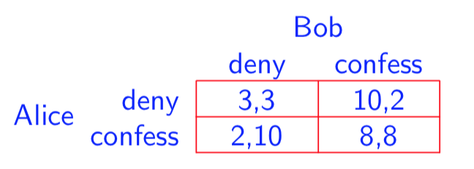Hence, when choosing best interest, harm is done to the opponent when choosing to Defect for own interest, the opponent may choose to Cooperate so have a worse outcome

**Example (1):** (8,8) is Pareto Inefficient equilibrium as it is reached by both aiming for low by confessing. Could be made better off by both acting for mutual gain (3,3)

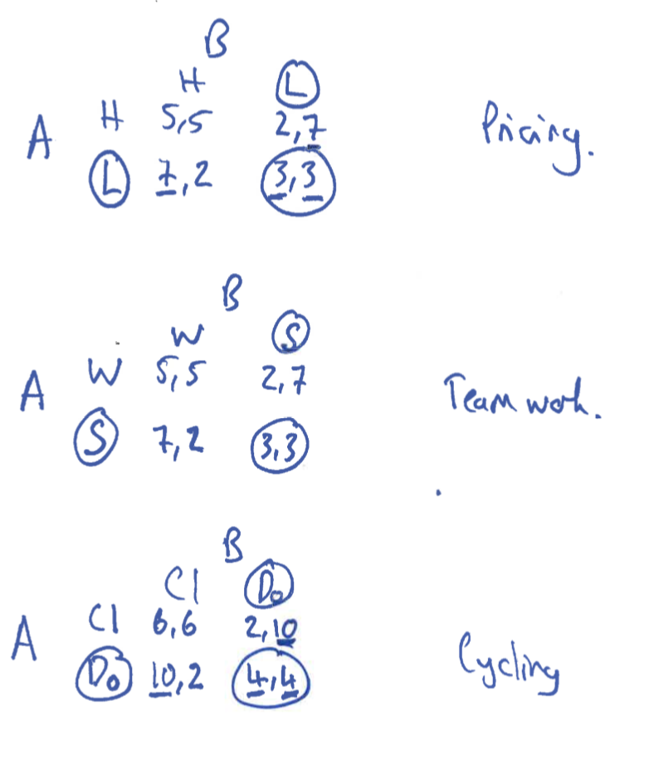**Example (2):** **Pricing** – non-brand loyal market, flow freely between

**Example (3): Team** **Work** – (work vs shirk) shirk leads to more payoff as still full marks but no work done but if the other does all the work, they will get full marks but payoff will reduce due to workload

**Example (4): Clean** **vs** **Dope** – (risk based) best self-interest response is to dope as highest possible payoff but the equilibrium they both do it is less than the payoff if they both don’t

**Example (5): Market Share** – studying marketing is a waste of time. Market is a pie, we compete over our share. Ads try to (1) inform & (2) predatory (winning market share). Start: 50/50, engage in ads to win market share. I spend money, I get some in return but you won’t gain much more market share. The opponents do this to keep up. Each keep catching back up to 50% each but both are still wasting millions on marketing. Market share isn’t changing proportionately but you’re still spending money

**3.1: Externalities**

* Negative Externalities: (own interest – doing too much) Cooperation reduces amount of work you do for the better (e.g. not over-fishing)
  + Don’t see costs from defecting – too much harmful activity is done
* Positive Externalities**:** (own interest – doing too little) Cooperation says you should do more work (e.g. not doing no work in a project)
  + Don’t see costs benefits form cooperating – too little of a good activity is done
* **Example**: Marginal Benefit vs. Marginal Cost – (1) extracting fish from the ocean makes it harder in the future (e.g. do less fishing to allow repopulation). (2) But you want more to sell now. (3) Self-interest makes it harder for others

**3.2: Rationalise Cooperation Resolutions**

* Resolutions to Prisoner’s Dilemma
* **Meet-up** (verbal agreement): let’s set high prices (incentive of deception however – you want him to set high prices and you want to set low)
* **Threaten**: punishment of opponent doesn’t set high prices (lacking credibility as you “will do it” rather than it “will be done (automatically etc.)” – can fix credibility by using Mafia as they have more incentive to harm him)
* **Reward**: offer a reward that overcomes the incentive to Defect (still lacks credibility as it involves giving money – lowers your payoff. May not even believe you)

**3.3: Behavioural Resolution**

* People are influenced by the ‘social norm’: if people conflict with this, there’s a cost
  + 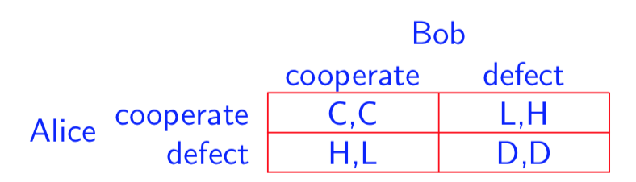Denote this cost of Defecting as ***k***
  + Recall:
  + 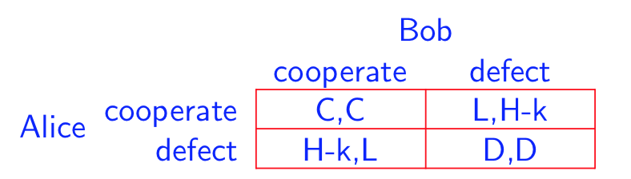H > C > D > L
  + So:
  + If ***k*** large enough relative to ***H – C***, behaviour in defecting contrasts with ‘social norm’ so cost
* External Norms of Behaviour:
  + Think back to litter e.g.: many people won’t actually litter even though it’s the most beneficial for you. It conflicts with the social norm
* Internal Norms of Behaviour:
  + Doing nice things for people who are nice to you (gain utility)
  + Being bad to people but they are good to you (loss of utility). - you defect but if you care enough, you’ll maybe rationalise Cooperation and change mind

**3.4: Price Matching Guarantee Resolution**

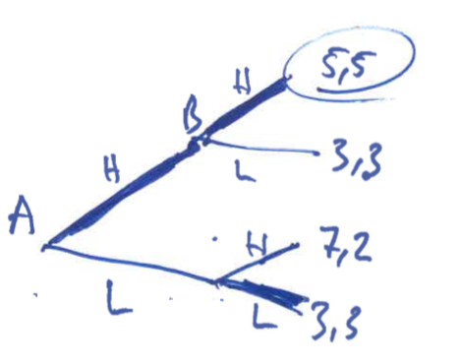

* You may be undercut for opponent to gain market share from you at lower prices
* If you’re offered. PMG, you will simply match prices and keep customers “he’s selling at that price, can you just sell me at that too”
* Opponent now doesn’t gain, just sells at lower price as no market gain
* Equilibrium of both pricing high – out of Prisoner’s Dilemma

**3.5: Dynamic Punishment Resolution**

* When Defecting, a player may believe they will be ‘punished’ in the future
* Can we achieve Cooperation through fear of Punishment?
  + **Credible:** backed with fact
  + **Incredible:** maybe won’t happen
* **Finite Period** (*T* Periods): Defect in last period as no more time for **retaliation**
  + Final period: mutual Dominant Strategy to Defect as no future punishment
  + So: best to defect this period as well as you both will next
* **Infinite Period:** the game will continue [probability p=1] so **retaliation**
  + Always an opportunity to punish as there’s always another period
* **Impatient:** future worth less than present so Defect (not caring for punishment)
* **Patient:** care more for future gain by waiting and Cooperating

***3.5.1: Discounting***

* **Stream of Payoffs:**
* £1 from £1 today to £1(1+*r*) tomorrow; £1 from £1 tomorrow to today
  + **PV**: ; ***r*** = Discount Rate; = Discount Factor =
  + **Hence**: £*X* in period *t* is worth today
  + **Hence**: £*X* in period *t* is worth today
  + Close to 1: **Patient;**  Close to 0: **Impatient**
  + ;
  + **Infinite:**
  + **E.g.** Payoff of 7 in perpetuity: Payoff of 10 today and 2 in perpetuity:
  + **;**

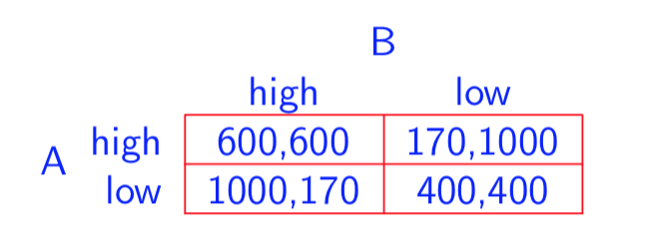**Note:**

***3.5.2: Trigger Strategies – Grim Trigger***

* Start by Cooperating
* If opponent Cooperated, Cooperate
* If opponent Defected, Defect in perpetuity

1. Cooperate:
   * Opponent gets 600 forever 🡪
2. Defect:
   * Get 1000 now but 400 after 🡪
3. Answer:
   * Hence: **Grim Trigger** at so Cooperate

***3.5.3: Trigger Strategies – Tit-For-Tat***

* Start by Cooperating
* Play as the opponent played in the last round
* Cooperation followed by Cooperation
* Defection followed by Defection

1. Defect in Perpetuity:
   * Same as **Grim**
2. Defect Once:
   * Get 400 now but loses 430 after 🡪
3. Answer:
   * Hence: **TFT** at so Cooperate

If **Grim** Works: Cooperation is **possible**

If **TFT** Works: Cooperation is **easy**

**4: Games With Continuous Strategies**

* This is applying maths to what we already know
* Nash Equilibriums & Sub-Game Perfect Nash Equilibriums remain the same
* This is applying the following more generally
* Matrix strategy: can choose any option for the expected opponent’s options
  + Recall:
  + Simultaneous: Best Responses & Mutually Consistent Best Responses
  + Sequential: Backward Induction
* Take a long time to analyse a Continuous Strategy using Discrete Sets (matrix)

**4.1: Quantity Competition**

* In a **Competitive Market**
* Firm *i* supplies
  + Where Total (Aggregate) Quantity: *Q*
* Inverse Demand Function:
* Payoff is Profit ():
* Hence:
* Oligopoly if several firms compete
* Recall that A could choose any option from 1 to NMatrix in response to B
  + “ could be anything from 1 to NMatrix”
* This can be reflected in chart form but can prove difficult in high Ns:

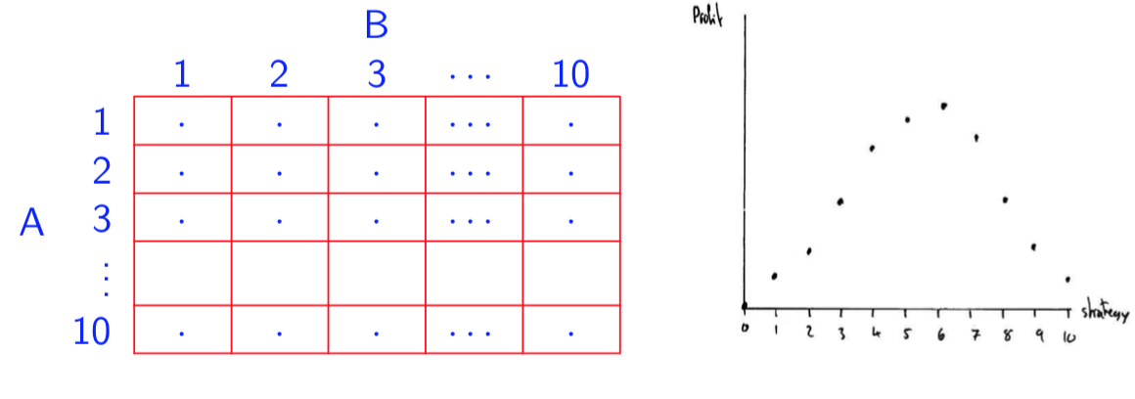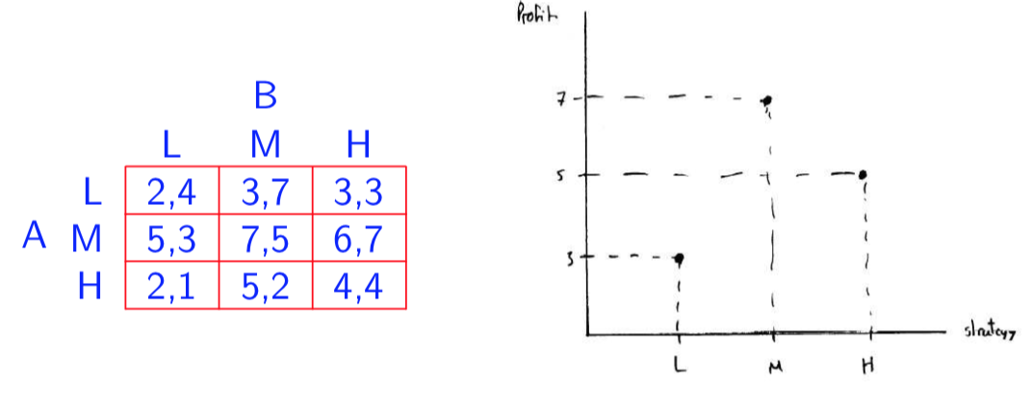

**…**

* + Hence, we see a Payoff Function which is maximised at a point
  + “Find the level of maximiseing firm 1’s payoff for given ”

**4.2: Continuous Strategies**

* Too hard to account for all the options (in this case quantities to produce)
* Recall Basic Maths:
  + Function: the level
  + Derivative: the slope of the function
  + Partial Derivative: fix a variable (extract from equation {Hyp. = 0})
* Recall **Rules of Differentiation**:
  + Working towards Payoff Function
  + Just like in the matrixes, fix the opponents option each time to find your best
  + Hence,
  + Fix (the other’s strategy) to observe how varies with
  + Therefore, **partial derivative:**  for fixed
  + Thus, Best Response at {} (peak of function)
  + Note that, if you take the derivative on the **incline** of the function, you can be made better off by doing more. Take the derivative on the **decline**, better off by doing less
  + 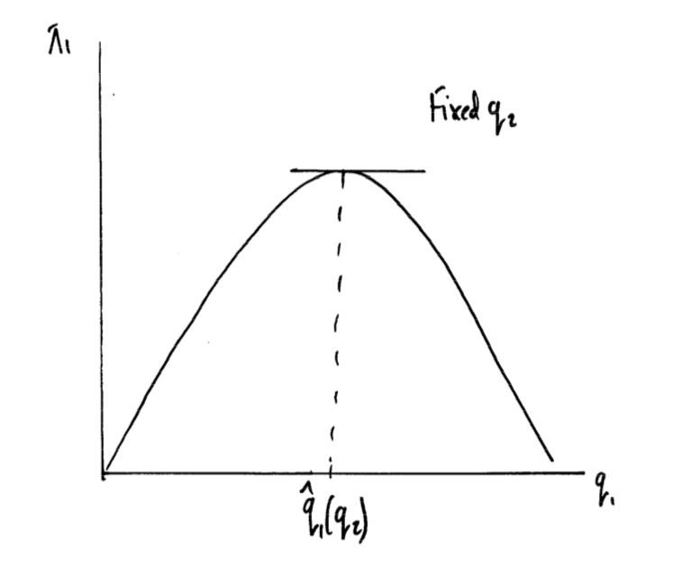



* + 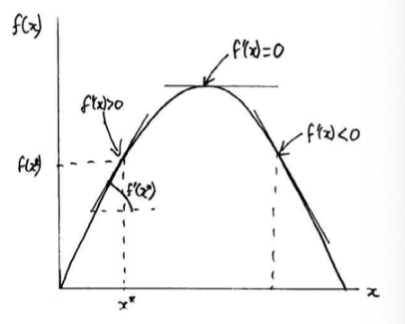Recall: the function :
  + Recall: if
    - **Constant**:
    - **Sum**:
    - **Product:**
    - **Chain:**
    - **Quotient:**
    - **Log:**
  + In Practice:
    - **Power**:
    - **Constant**:
    - **Sum**:
    - **Product:**
    - **Chain:**
    - **Quotient:**

**4.3: Cournot Derivation of Payoff & Reaction (Simultaneous)**

1. Fix **Firm 2**’s action and find my Best Response through Payoff Function
   * Find Payoff Function
   * Partially Derive & {=0} for Best Response with fixed
   * Find best for Reaction Function; Sub for
2. Fix **Firm 1**’s action and find their Best Response through Payoff Function
   * Find Payoff Function
   * Partially Derive & {=0} for Best Response with fixed
   * Find best for Reaction Function; Sub for
3. Find meeting point of **Nash Equilibrium** where both firm’s Reaction Functions meet
4. (Optional) Substitute to find the optimal π for each firm

* **Players**: 2 firms of
* **Strategies**: each firm chooses quantity of
  + For Quantity
* **Payoff**: given supply choices,
  + Marginal Cost of
  + Price
  + Payoff (Profit)
* Working Example for **Firm 1**:
  + For :
  + (Payoff Function of Firm 1)
  + (Fixed )
  + … (Reaction Function of Firm 1)
  + Recall:
  + Note that Reaction Function:
  + Hence, Reaction Function:
  + Output quantity should decline as the opponent’s increases
  + 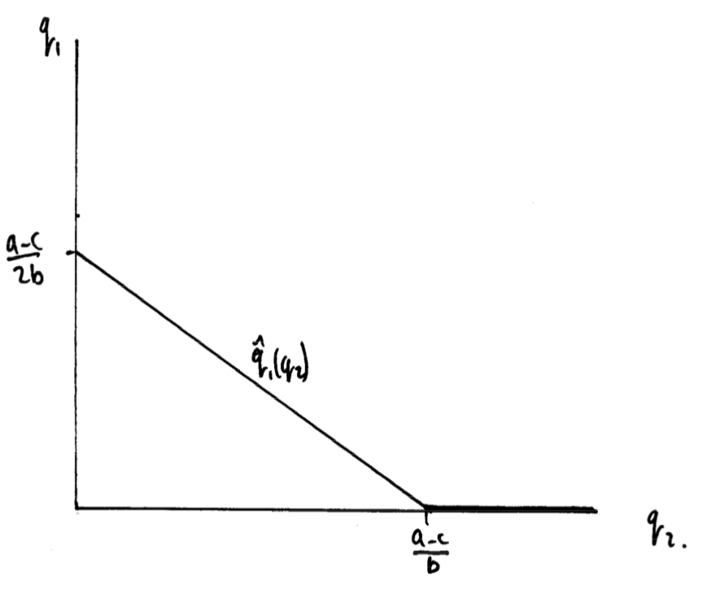When it reaches 0, leave market
  + Obviously no negative
* Repeat for **Firm 2**:
  + (Payoff Function of Firm 2)
  + (Fixed )
  + or (Reaction Function of Firm 2)
  + Note that Reaction Function:



* **Nash Equilibrium**:
  + “The Cournot Equilibrium”
  + Flip Firm 2’s Reaction Function and overlay
  + Seek:
  + “For Firm 1’s *q* which maximises its π given Firm 2’s *q*”
  + “For Firm 2’s *q* which maximises its π given Firm 1’s *q*”

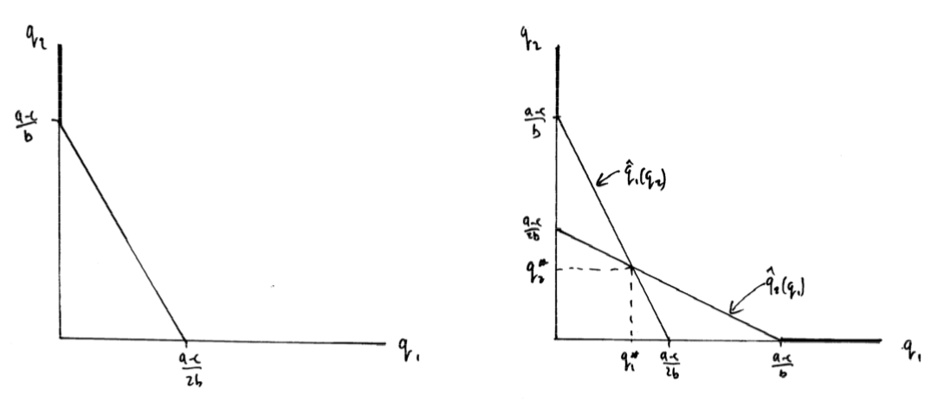

* + Achieved through **Substitution**
  + From:
  + Sub for Firm 2…Sub for π’s…
* Cournot Equilibrium **
  + Hence:
  + So:
  + Thus:
  + ;; ;
* Verify that:
  + Industry Output Between Monopoly and PC:
  + Price is Between Monopoly and PC:
  + Industry Profit Between Monopoly and PC:

**4.4: Stackelberg Leader & Follower (Sequential)**

* The leader implements the first player’s Reaction Function intro their Payoff Function
* First mover advantage as leader gets higher payoff
* Recall from Sequential Games: Backward Induction
* **Linear Demand**:
* **Constant Marginal Costs**:
* **Profits**:
* Firm 1 moves, Firm 2 observes and moves
* Firm 1: Leader; Firm 2: Follower
* 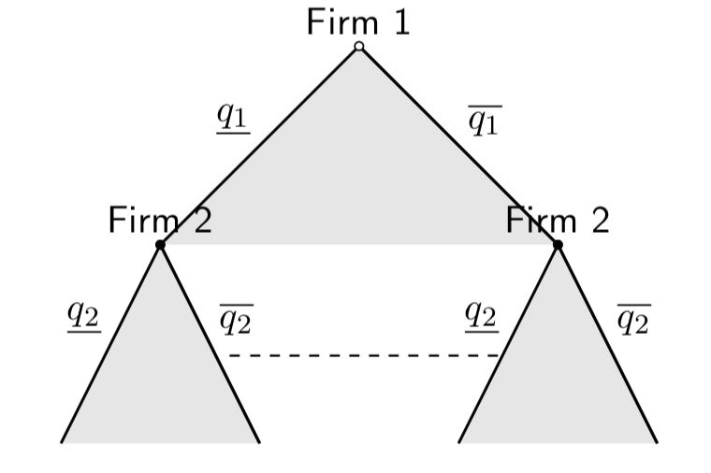Recall Observation:
* Backward Induction:
  + Stage 2: Firm 2 maximises profits given

Firm 2 uses Best Response to whatever Firm 1 produces

* + Stage 1: Firm 1 anticipates reaction of Firm 2 to any decision made

Firm 1 maximises profits given response of Firm 2

Firm 1 chooses point on Firm 2’s Reaction Function which maximises profits

* **Stage 2:**
  + Given what’s the best for Firm 2 (follower) to do? – As Previously…
  + Recall: (Payoff Function)
  + Optimise and {=0}:
  + React: (Reaction Function)
* **Stage 1:** 
  + Firm 1 (Leader) will choose to max. profits taking into account the reaction of the follower
  + Recall: (Payoff)
  + It Knows: if they choose Firm 2 will respond with – account
  + Firm 1 (Leader):

* So Firm 1 Maximises:
* Therefore: (Reaction)
* So Firm 2 (Follower): (Reaction)
* Stackelberg Equilibrium **
  + Idea Is: rather than equilibrium, there is an advantage
  + ; ;
* Stackelberg vs. Cournot:
  + Cournot: ; ; ;
  + Stackelberg: ;

;

; ;

* Hence, First Mover (Firm 1) Advantage!

**5: Applications of Prisoner’s Dilemma**

**5.1: Recalling The Cournot Game**

* An example of a continuous game
* Rather than using Reaction Functions, find Isoprofit Curves
* This is like indifference curves for firms
* Call Firms:
* Strategies:
* Payoff:

***5.1.1: Typical Reaction Function***

* + From Isoprofit contours
  + Equilibrium at intersection:

***5.1.2: Maximising Joint Profit***

* Hence: assuming ;
  + Makes sense as:

***5.1.3: Will Firms Agree?***

* Will firms agree to produce at half the monopoly output?
* **No**: if firms expect you to produce more than ;
  + Best possible: 🡪 must expand output in excess of Cournot Output
  + Defecting firm: **Bonanza** Payoff
  + Cooperating firm: **Sucker** Payoff
* 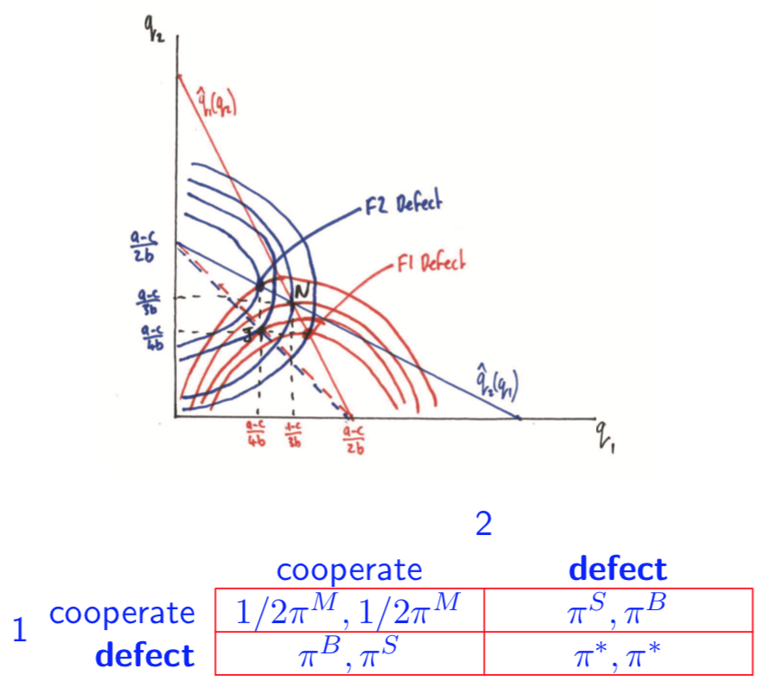Hence: Prisoner’s Dilemma

**5.2: Externalities & Strategic Nature**

***5.2.1: Externalities***

* **Negative**:
  + You do more, you lower my payoff (Cournot Game)
  + (Slope of Payoff Function)
* **Positive**:
  + You do more, you lower my payoff
  + (Slope of Payoff Function)

***5.2.2: Strategic Nature***

* **Strategic Substitutes**:
  + Opponent does more of their action: you optimally do less (Reaction Function downward)
  + “with a higher *xj* the optimum is with a lower *xi*”
* **Strategic Compliments**:
  + Opponent does more of their action: you optimally do more (Reaction Function upward)
  + “with a higher *xj* the optimum is with a higher *xi*”

**5.3: Nash Equilibrium in Games**

* When non-cooperative, players optimise self-interest
* Marginal Payoff = 0: &
  + *Note that hat implies function*
* Nash Equilibrium at: Equilibrium
  + Thus Nash Equilibrium actions:

**5.4: Social Planner**

* What happens when they ‘internalise’ the externality?
* Social Planner maximises joint payoff
  + - Chooses to maximise
    - 🡪 these are both Social Optimums

**5.5: Nash Equilibrium vs. Optimum**

* w/ **Positive Externalities**
  + 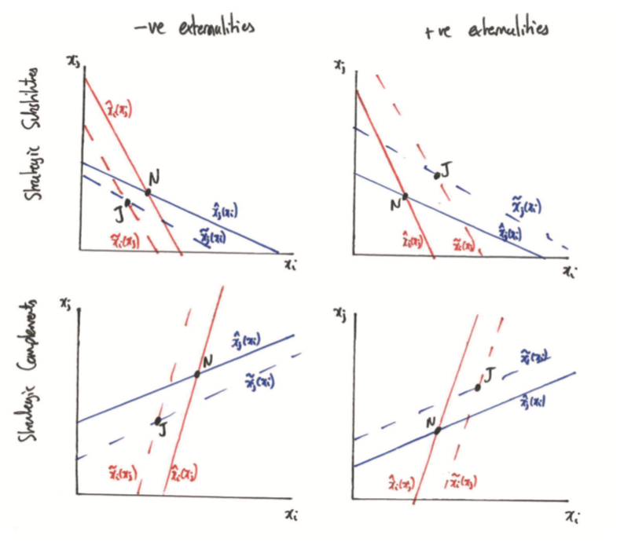{}
  + So for Social Planner {}
  + So:
* w/ **Negative Externalities**
  + {}
  + So for Social Planner {}
  + So: